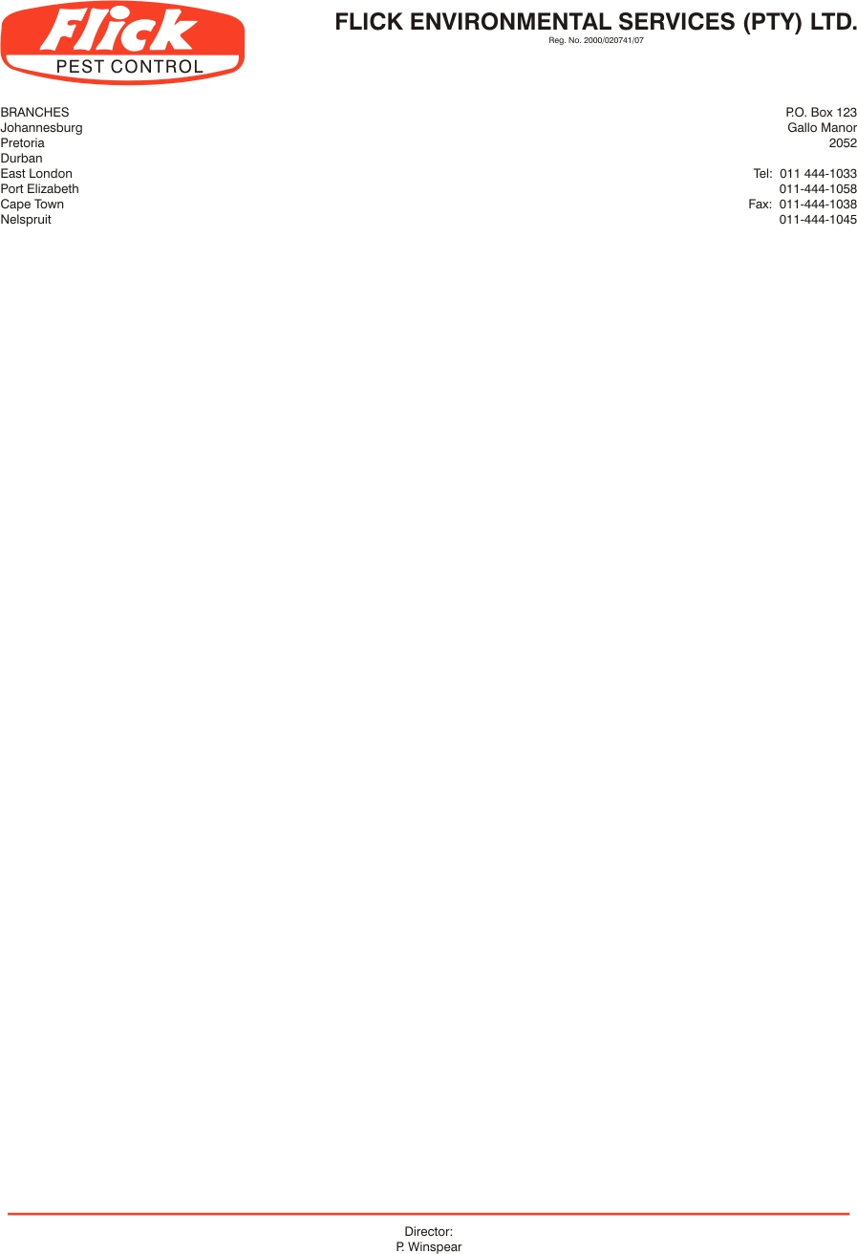

Invoice to: Dinner Mates PO Box 1050, Honeydew, 2040

VAT no: 4110123314

Contact person: Morgan Tel: 0114620020 / accounts@dinnermates.co.za

Service address: 20 Precision Road, Kya Sand

SERVICE AGREEMENT 12728

- FLICK PEST CONTROL agrees to carry out inspections and treatments at the addresses noted above to bring under control any infestation of cockroaches, rats and mice and black ants
in the following areas: Treat as per Pest control Policy. Service all external rodent bait stations. Treat all drains, main kitchen and canteen. Service office area including bathrooms, kitchens and store rooms. Treat as per HACCP standards. Complete file with each visit.

- FLICK PEST CONTROL agrees to carry out such further inspections and treatments as may be necessary to maintain control of these pests on these premises. Services will be done on a monthly cycle to maintain control of the above pests. (Minimum of 12 treatments and inspections per annum)

- In the event of re-infestation by specified pests anytime during the life of the agreement, FLICK PEST CONTROL will make additional inspections and treatments as to re-establish control of the pests at no extra charge to the client.

- The client agrees to pay for these services at the rate of R 1030.00 (Exc. VAT) for the initial service. Thereafter R1030.00 (Exc. VAT) monthly. The first payment is due on the commencement of the agreement and the subsequent payments monthly thereafter. This price is subject to inflationary increases which take effect periodically.

- This agreement is binding for one year from this date. Notice in writing is required to terminate the agreement at the end of the fist year, or thereafter 3 months notice.

Signed this_____ 16th day of July 2013

Client signature: ________________________ For Flick: _______________________
Client name: Sanet Haupt

